🟢 Bandit Level 3 → Level 4
After logging in as bandit3, run:
Ls -al to view the hidden files
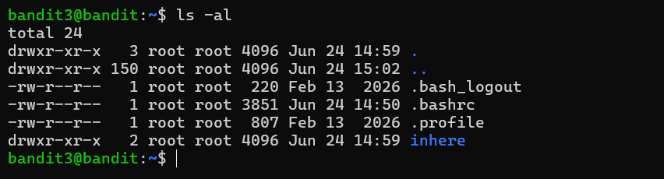
You'll see a directory:
inhere
Go inside it:
cd inhere

Now run:
ls -la
You should see a hidden file:
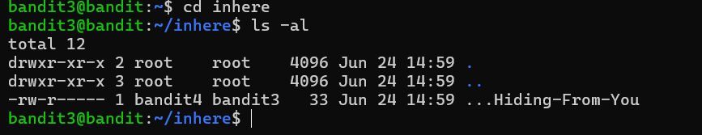
Run cat ./...Hiding-From-You
🔑 The output is the password for bandit4. xzTXq1rDJQVVAzdv5cHq1TQytTWufAMq
Then exit from that level

